Business Manager Workflow Guide
Oct 4, 2026 · @Joao Azevedo

Overview
Business Manager is a Discord-style team management app: a team leader instructs the team, members file daily reports and weekly or monthly plans, and Checkout compares the plan with what actually happened. It is built on MongoDB, Express, React and Node, with Socket.IO so instructions, chat and record changes appear live on every screen.
The screen has four parts, left to right:
- Channels (left rail): Instruction, Report, Plan, Checkout, Task, Assets, Member, Finance, Chat, Admin.
- Titles (middle column): a tree, up to three levels deep. In group-scoped channels it goes period or type, then All or a group, then the members of that group.
- Content (main area): the records for the selected channel and title, with the form to add or edit them.
- Side panel (slides in from the right edge): profile, alert settings and the alerts list.
The header shows the logged-in user, their role badge, a live-connection dot and the alerts bell. Period and group live in the URL, so any view can be bookmarked and shared.

Roles and hierarchy
Reading follows the hierarchy: the leader and admins see everything, a boss sees their own group, a member sees only their own records. The server enforces this, so an out-of-scope record answers 404 and the title tree only offers what the role may open.
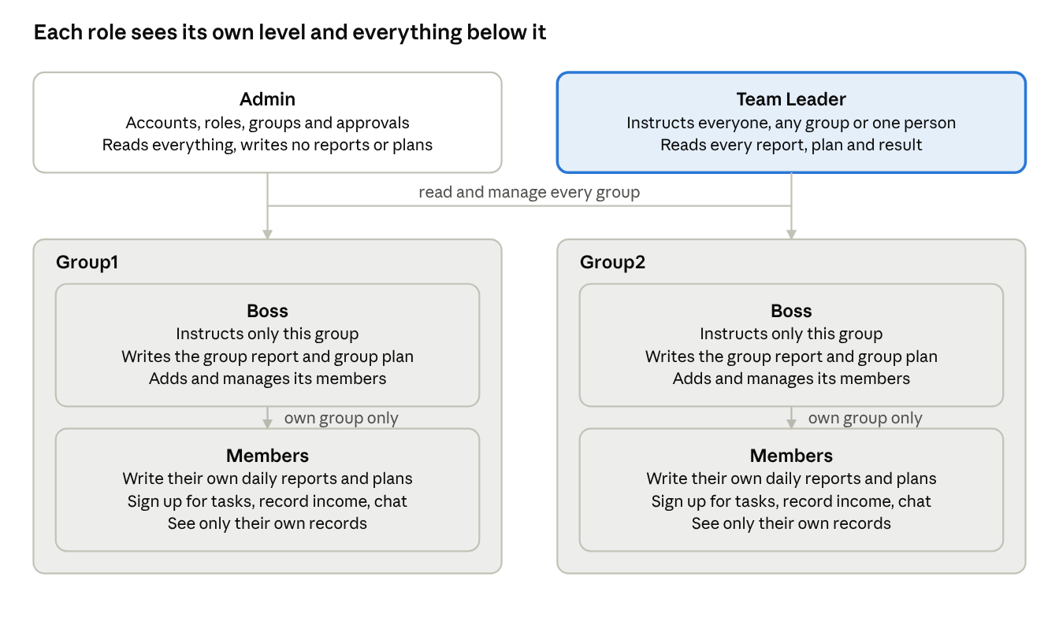
role hierarchy · 4 roles, one boss per group
Every group works the same way as the two drawn here. Capabilities are defined once in the server's roles config; the per-record rules live in the policy files under the server utils folder.
Role | May do | May not do
Admin | Approve sign-ups, change roles, create and rename groups, add members, reset passwords, disable accounts, delete any chat message | Write reports or plans, send instructions, record income or outcome
Team Leader | Instruct everyone, a group or one person; read all reports, plans and results; record income and outcome for anyone; create tasks and assets for anyone; approve sign-ups; delete any chat message | Change roles or groups; write a personal report or plan
Boss | Instruct their group or one of its members; write the group report and group plan; write their own personal report and plan; add and approve members of their group; record income and outcome for their group; reset passwords in their group | See other groups; change roles
Member | Write their own daily report and weekly or monthly plan; sign up for tasks; record their own income; keep their own assets; chat in general, finance and their group | See anyone else's records; send instructions; record outcome

Onboarding workflow
A new person is either invited by someone above them or signs up and waits for approval. Nobody can use the app until their account is active and placed in a group.
- First start. The server creates the admin account from the seed settings in the env file, plus the groups Group1 and Group2. The admin must choose a new password at first login.
- Groups. The admin creates or renames groups under Admin → Groups. A group keeps its address when renamed, so links keep working. Deleting a group leaves its records under "No group".
- Adding people. Two roads:
  - Invited: the admin, the leader or a boss adds the person under Member → Add member (a boss only into their own group). The form prints a temporary password that must be changed at first login.
  - Self sign-up: the person registers on the sign-up page and lands in the Approvals list with status pending. The admin, the leader or the group's boss approves or rejects them under Admin → Approvals. Until then, login answers "Your account is waiting for approval".
- Roles. Only the admin changes roles, under Admin → Users & roles. Promoting a member to boss gives them the group report and plan and the management of that group.
- Moving a member to another group moves their tasks, income, outcome and assets with them. The new boss sees and manages everything, the old boss no longer does. Group reports and plans a boss wrote stay with the group they were written for.
- Passwords. Anyone resets their own password in the side panel. The leader and bosses reset a member's password in the Member channel, which logs that person out everywhere. A forgotten admin password is reset from the command line:
npm --prefix server run reset-password -- <username>
- Leaving. Disabling an account (Member channel or Admin) logs the person out immediately and keeps their records, which still count in totals as "(disabled)".
Password rule: 8 to 128 characters with at least one letter and one number. Ten wrong passwords lock that username from that network for 15 minutes.

Daily workflow
Each working day runs in three steps: the leader and bosses instruct, everyone works and talks in chat, and every member and boss files one daily report before the day ends.
- Instructions go out (morning). The leader instructs everyone, a group or one person; a boss instructs their own group or one of its members. Pick a person under a group in the title tree and the composer addresses them directly. Mark it urgent when it must be seen now.
- Instructions are read. Each new instruction raises a sound, an in-window popup and, if allowed, a desktop notification. An urgent one keeps alarming until the reader presses "Got it". The sender sees "Read by N of M" and who is still missing, and can chase them. A direct instruction is private: only the recipient, its author, the leader and admins can read it.
- Work and chat (all day). General and finance chat are open to every member; a group chat is for that group plus the leader and admins. Messages show typing indicators and unread markers. Authors edit their own messages; the leader and admins can delete any.
- Daily report (end of day). Every member and boss files one personal report per day under Report → My report, with: job bids, AI training bids, income, upcoming amount, an upcoming note and a note. Saving again the same day updates it. Nobody can change someone else's report, whatever their role.
- Group report. Each boss also files one group report per day for their group. Any boss of the group can write it; the last save wins and names its author.
- Review. The leader and admins read every report under Report → All or a group; a boss reads their group's. Members who have not filed today show as missing in the team table.
Reports are daily only. The report form has no task field; tasks are tracked in the Task channel.

Weekly and monthly workflow
The week starts with a plan, fills with daily reports, and ends with the owner marking the result; Checkout then shows plan against report against what was actually earned.
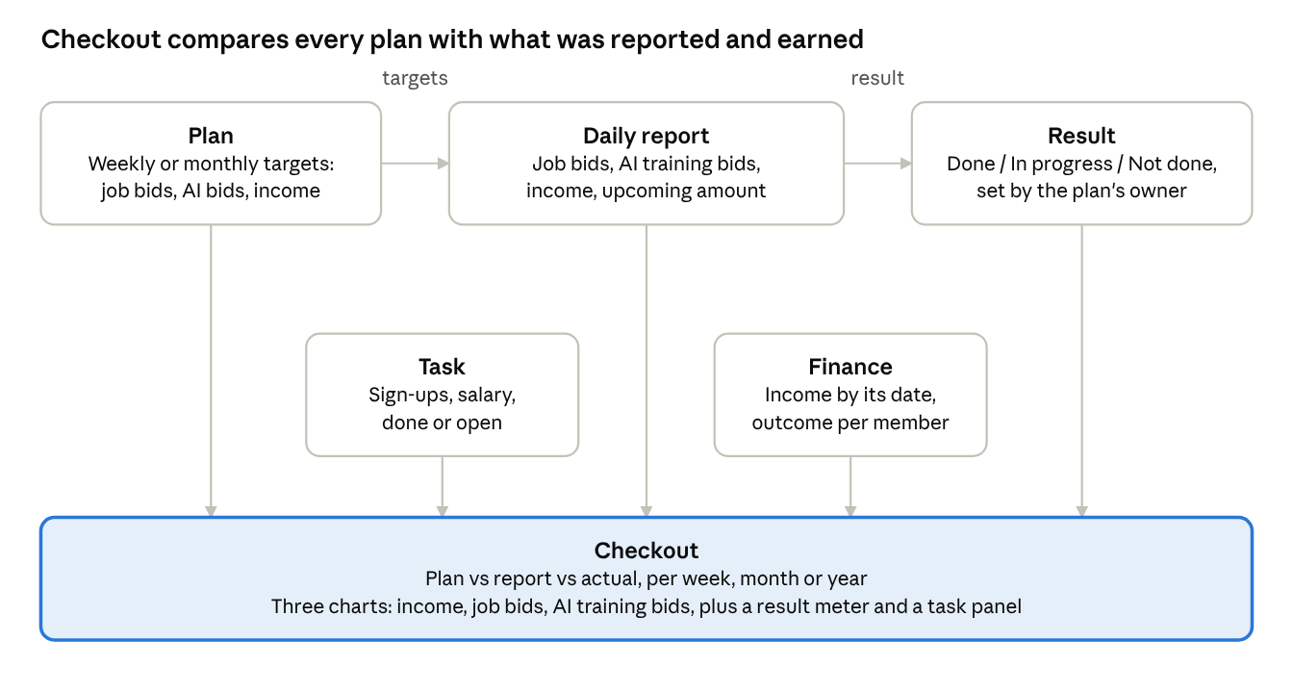
plan, report and checkout cycle · 5 sources, 1 result
Plans set the targets the daily reports are measured against; the owner marks the result; Checkout draws all of it together with the Task and Finance channels.
- Monday: plans. Every member and boss writes one personal plan for the week (and one for the month at its start) under Plan → Weekly plan or Monthly plan. The targets are job bids, AI training bids and income, the same three numbers the daily report asks for. Daily plans do not exist.
- Group plan. Each boss also writes one group plan per period. Any boss of the group may write it; the last save wins.
- During the period: reports. Daily reports accumulate (see Daily workflow). Nothing in the plan changes automatically.
- End of period: result. The plan's owner sets its result to Done, In progress or Not done. A summary meter counts the three states for the team or group.
- Review in Checkout. Pick Weekly, Monthly or Yearly, then All, a group or a member. Three charts in one row compare plan and result for income, job bids and AI training bids. Below them sit the plan-result meter and a Tasks panel (done, open, salary). It refreshes live when any source channel changes.
Checkout counts personal plans and reports only, since a group plan would double-count. It counts tasks that overlap the period and income by its date. A period belongs to where it starts: the week of Sep 28 to Oct 4 counts for September, and the last week of a year for that year.
Period | Plan | Report | Checkout
Daily | no | yes, one per person per day | no
Weekly | yes | summed from the days | yes
Monthly | yes | summed from the days | yes
Yearly | no | summed from the days | yes

Tasks and finance workflow
Money follows the member: tasks, income, outcome and assets always belong to one member or boss, and the leader and admins record them for someone, never for themselves.
Tasks
- The leader, a boss or the member creates a task under Task with an owner, a name, a start and end date, a salary and a note.
- The owner moves its progress through Not done, In progress and Done.
- Checkout's Tasks panel counts the tasks that overlap the period: done, open and total salary.
Income
- A member records their own income under Finance → Income: date, amount and where it came from. Bosses and the leader record it for the people they manage (Record income), optionally linked to a task.
- Income records are history and cannot be changed afterwards.
- Checkout counts income by its date; Finance → Total sums it per period and group.
Outcome (money spent)
- Only the leader and bosses record outcome, under Finance → Outcome: date, amount, reason, comment and at least one image as proof.
- A team or group outcome is split equally into one share per member, so every share stays tied to a person. The shares are linked and show the total they came from.
- The author can edit or delete an outcome; images nobody references are removed after a day.
Totals
Finance → Total and Checkout list everyone who has records in the period, including an account since disabled (shown as "(disabled)") or a member since promoted. Records with no group sit under a "No group" tile. Long lists show the newest 500 records; totals and charts count all of them.
Assets
An asset is a profile a member works with: name, birthday (age is worked out from it), nationality, contact info, English level and a note. The leader and admins create them for anyone, a boss for their group, a member for themselves. The Member channel shows each member's assets as one sentence per asset, only to people who may see that member.
Record | Who writes | Who reads | Can it change later
Task | leader, admin, boss (own group), member (self) | same scope | yes, owner updates progress
Income | member (self), boss (own group), leader | same scope | no
Outcome | leader, boss (own group) | leader, admin, boss (own group), the member | yes, by its author
Asset | leader, admin, boss (own group), member (self) | same scope | yes

Channel reference
Ten channels cover the whole workflow. In the group-scoped ones the title tree is three levels deep: the type or period, then All or a group, then that group's members. A member has no group level and sees "My report" or "My assets" instead.
Channel | Titles | What it holds | Who writes
Instruction | All · each group · each member | Instructions with read receipts and a live alarm; direct ones marked Direct | leader (anyone), boss (own group)
Report | All · each group · each member (member: My report) | Daily reports: job bids, AI training bids, income, upcoming amount and note, note | member and boss (own), boss (group report)
Plan | Weekly / Monthly, then All · group · member | Targets for job bids, AI bids and income, plus the Done / In progress / Not done result | member and boss (own), boss (group plan)
Checkout | Weekly / Monthly / Yearly, then All · group · member | Plan vs report vs actual: three charts, result meter, task panel | nobody, it is computed
Task | All tasks · each task name | Owner, name, period, salary, progress | leader, admin, boss (own group), member (self)
Assets | All · group · member (member: My assets) | Profiles: name, age, birthday, nationality, contact, English level | leader, admin, boss (own group), member (self)
Member | All · group · member | Directory with each member's assets in one line; add members, reset passwords, disable accounts | admin, leader, boss (own group)
Finance | Income / Outcome / Total, then All · group · member | Income and outcome per member; totals per period and group | income: member, boss, leader; outcome: leader, boss
Chat | general · each group · finance | Live chat with typing indicators and unread markers | everyone in scope
Admin | Approvals · Users & roles · Groups | Sign-up approvals, role changes, group management | admin (approvals also leader and boss)
The channel titles come from the nav endpoint, built per user, so a new group, member or task appears everywhere without a code change. Unread counts show as badges on Instruction and Chat.

Running and maintaining the project
One command starts everything for development; one process serves everything in production. The repository is denniskramer-spec/Team_Project.
Development setup
- Start MongoDB. This project uses the Docker container business-manager-mongo (mongo:7, host port 27018).
- Copy server/.env.example to server/.env and fill in the Mongo URI, a long random JWT secret and the seed admin username and password.
- Install everything, then start the API, the client watch build and the client:
npm run install:all
npm run dev
- Open http://localhost:3000. The API listens on port 5000 and reports its state at /api/health.
Scripts (run from the project root)
Script | What it does
npm run dev | API with nodemon, client watch build, client on port 3000
npm run build | Production build of the client into client/dist
npm start | Runs the API; with NODE_ENV=production it also serves the built client
npm test | Server unit tests: periods, permission rules, outcome splits, paging, validation
npm run seed:demo | Fills an empty database with a demo team (password demo1234); --force --confirm=<db> wipes first
npm --prefix server run reset-password -- <user> | Gives one account a temporary password; set RESET_PASSWORD to choose one, add --no-must-change to keep it
npm --prefix server run dedupe-group-records | One-off: keeps one group report and plan per group and period; -- --apply to change data
npm --prefix server run split-legacy-outcomes | One-off: splits old team costs into one share per member; -- --apply to change data
Production
npm run build
NODE_ENV=production npm start
Put it behind HTTPS (the session cookie is marked Secure in production), set TRUST_PROXY=1 behind a reverse proxy, and set CLIENT_ORIGIN to the public address. Uploaded images live in server/uploads or UPLOADS_DIR; each database needs its own folder.
Code layout
Folder | Holds
server/src/config | env, roles and capabilities, the channel tree, the database connection
server/src/models | User, Group, Instruction, Message, ChatRead, Report, Plan, Task, Income, Outcome, Asset, Counter, RevokedToken
server/src/routes | one file per API area
server/src/utils | policies (member, instruction, report, chat, visibility), periods, validation, seeding, uploads
server/src/socket | Socket.IO rooms and event helpers
client/src/layout | header and the four sections
client/src/channels | one folder per channel, registered in channels/index.jsx
client/src/alerts | instruction alarm: sound, popup, desktop notification
Troubleshooting
- Node 20 or newer is recommended; the app also runs on Node 18.
- A # in the folder path breaks Vite's dev server, so npm run dev rebuilds the client on each save and serves it with vite preview. There is no hot reload; refresh after a change. Rename the folder to use npm --prefix client run dev:hmr.
- MongoDB 8 will not start on Linux kernel 6.19 or newer, which is why the container runs mongo:7.
- If MongoDB is down the API stays up, retries every 5 seconds and answers 503 on /api/*.
- Changing a password logs out that user's other sessions; disabling an account logs them out immediately.

Rules and conventions
These rules are enforced by the server, so every client and script sees the same behaviour.
Periods
- Weeks are ISO weeks in UTC, so 2026-W40 means the same for everyone. Keys look like 2026-10-04 (day), 2026-W40 (week), 2026-10 (month), 2026 (year).
- A period belongs to where it starts: a week that straddles two months counts for the month it begins in; the last week of a year counts for that year.
- Period and group live in the URL (?g= for the group, ?m= for the member), so any view can be bookmarked.
One record per period
- One personal report per person and day; one personal plan per person and period. Saving again updates the existing one.
- One group report per group and day; one group plan per group and period. Any boss of the group may write it; the last save wins and names its author.
Ownership
- Tasks, income, outcome and assets belong to members and bosses. The leader and admins record them for someone, never for themselves.
- Nobody edits another person's report or plan, whatever their role.
- Income is never edited after it is saved. Outcome is edited or deleted by its author.
- Moving a member moves their records; deleting a group leaves its records under "No group"; disabling a member keeps their records in every total.
Limits per person
Action | Limit
Changes of any kind | 120 a minute
Chat messages | 20 in 10 seconds
Instructions | 10 a minute, 3 of them urgent
Open tabs or devices | 10
Wrong passwords | 10, then that username is locked from that network for 15 minutes
Older data
- A report or plan written before bids were split counts its old bid as job bids.
- A report's old free-text "upcoming" shows as the upcoming note.
- Team outcomes recorded before the split existed are divided per member by the split-legacy-outcomes script.

